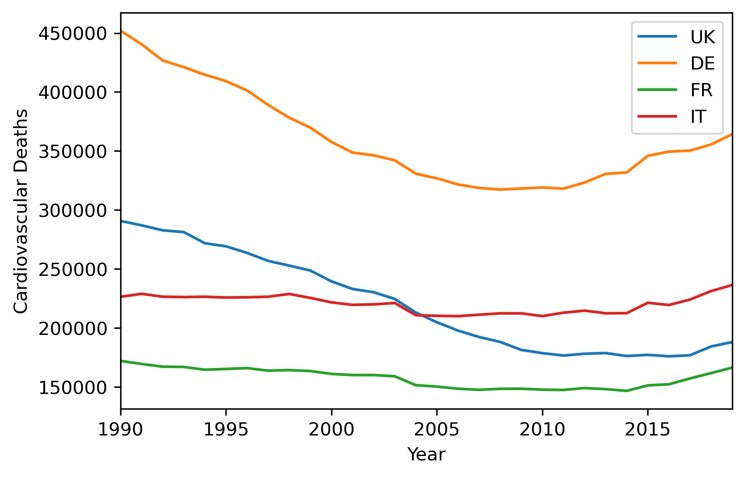  
The line plot shows the number of deaths due to Cardiovascular Diseases(CVD) during the year 1990 to 2019 for 4 countries in Europe. I felt a line graph was better suited for this because we can easily see the change in the number of deaths as years pass.

From the graph, we can see that Germany and UK had steady decrease till the around 2010 and 2015, after which it started to increase. For Italy, It was steady till 2015, and started to increase, whereas in France, it was always slightly increasing. The right side of the graph shows that CVD is increasing in all 4 countries in recent years.

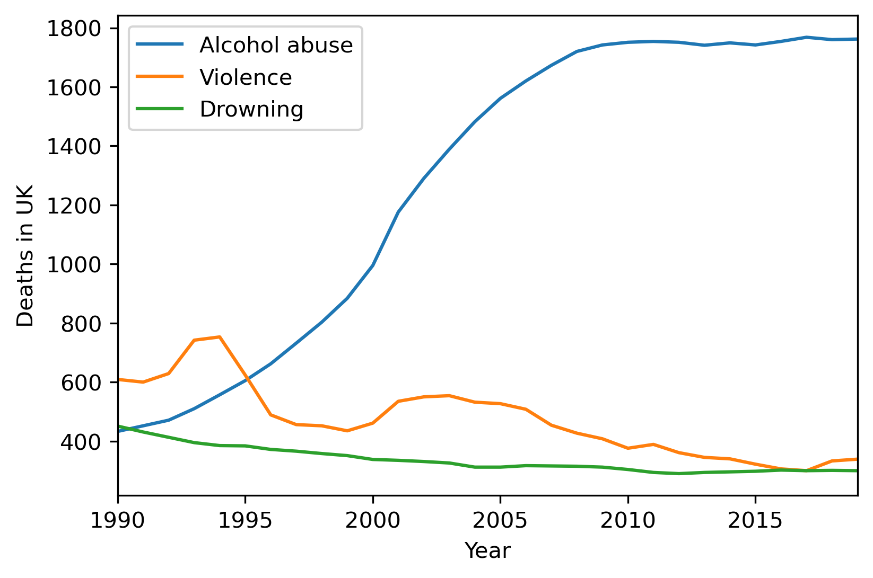  
  
  
This line plot shows number of deaths due three different causes in the United Kingdom from 1990 to 2019. I chose a line graph because we can see the difference in number between multiple causes, and the change in number of deaths of each cause during the years.

From the graph, we can see that in 1990, Alcohol abuse had slightly less umber of deaths than drowning, but then it has increased dramatically over the years, while drowning deaths have decreased in number. Deaths due to violence have gone up and down over the years, but decreased over time.

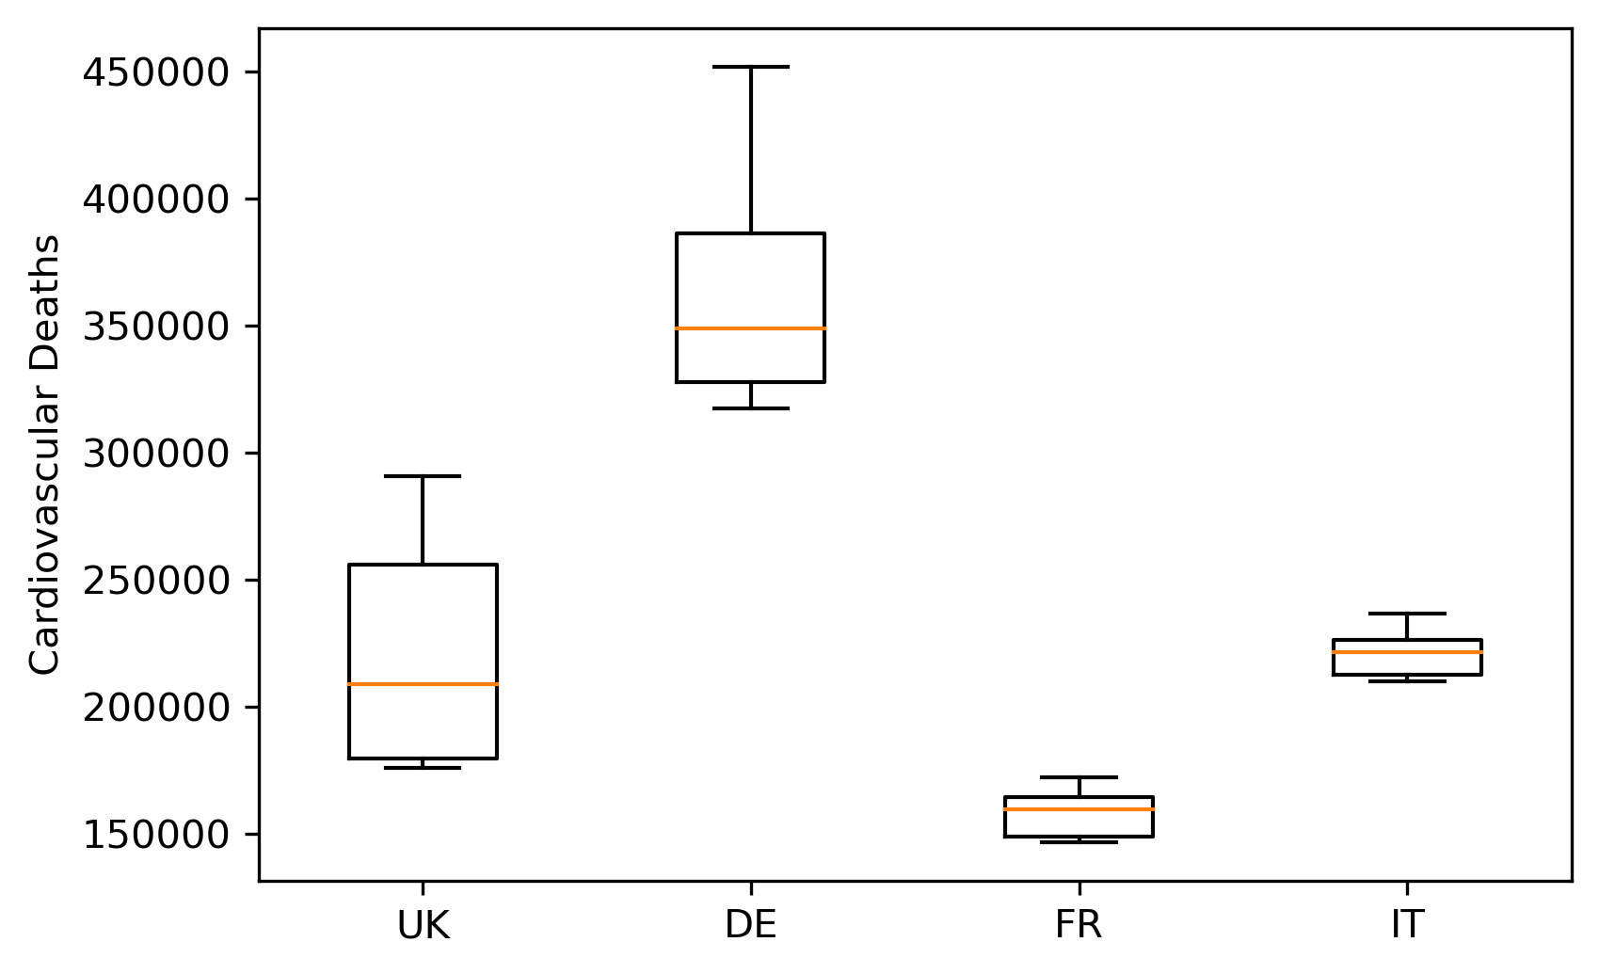  
  
This box plot shows average trend of the 4 countries on CVD. I chose a box plot becuase it shows us the distribution, outliers, and mean of the data. We can see that median is closer to the lower quarter for UK and Germany, showing a positive skew and closer to upper quarter for France and Italy, showing a negative skew.  
We can also see a larger range of scores for the first two, meaning a wider distribution of data and a much smaller range of scores for the last two, showing a narrow distribution of data.

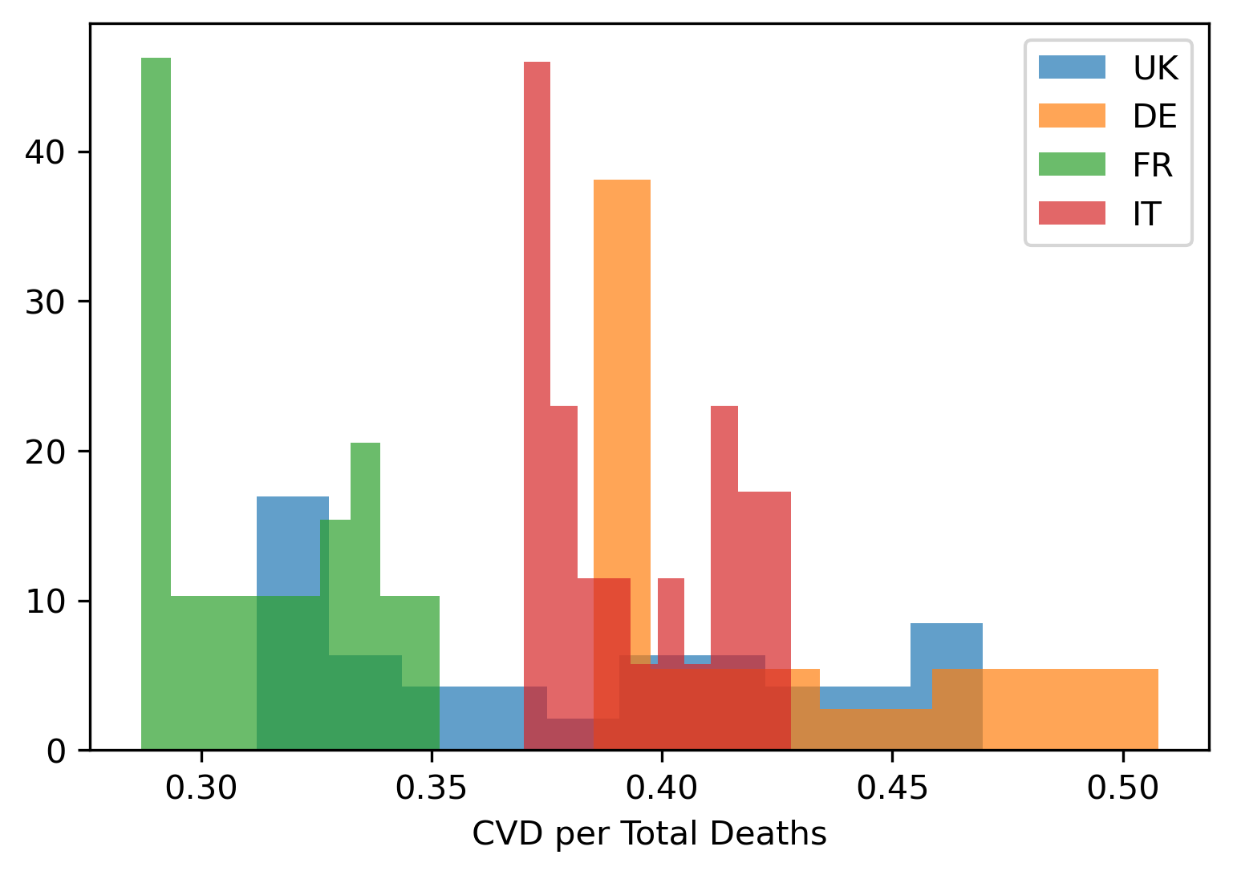

This graph shows the histogram of CVD per total deaths for five countries. I chose this graph because we can clearly see the frequency distribution of the values. It makes it easy to see which values are most common and which are least common

Here we can see that Italy, UK, and France have a non-symmetric bimodal distribution and Germany has a right-skewed distribution. For France, Germany, and Italy, a high number of CVD per total deaths happen at the left side, which is between 0 and 0.30 for France, between 0.35 and 0.40 for Italy, and between just below 0.40 for Germany.

Github repo Link: